Programming with Prolog

You can download PORLOG books and tutorials at these sites:
- http://www.ida.liu.se/~ulfni/lpp/
- http://www.thefreecountry.com/documentation/onlineprolog.shtml

Using swi-prolog (http://www.swi-prolog.org/)
- Install swi-prolog (version 9.0.x),
- Use a text editor (ex., notepad++ editor) to create your prolog program file
- Save with extension you specified during install, (ex., pl)
- Double click on the file name to open with swi-prolog. This will start swi-prolog and compile, load your program.
- If your program does not compile, the line number where error is will be indicated.
- Test with queries if your program was compiled successfully.
- To trace the execution of a functor , use spy(functor), nospy, guitracer, noguitracer, gspy(functor)(spy+guitracer), etc
- Use PgDn to get a new(?) screen

The Basic Prolog Elements:
- Terms – represent data objects
- Facts - represent relationships between data objects
- rules – represent relationships between facts
- queries – questions about facts

1. Terms
There are 4 types of terms

Constants

Numbers (or numeric atoms)
- Strings (in ‘ ‘),
- Symbolic atoms (symbol)
Begin with a lower-case letter, followed by letters, digits, and _
Ex., grandfather, ted, don, east, west

Variables
- Begin with an upper-case letter, or _, followed by letters, digits, and _
- Declarations are not necessary in swi prolog
- Each variable is bound to ONE value for each solution during execution to prove a goal, answer a query, or solve a Constraint Satisfaction Problem (CSP).
- The variable-value binding process is called resolution.

Structures
- Used to specify facts or relationships
- Form:
Functor(parameter list)

Functor: symbol
Parameter list (also called components of the functor):
term, term, …

BNF notation for <parameter list>:
<parameter list> → term{,term}
Ex.,
belong(colts, nfl).

- Internal representation: tree

functor

term … term

D. List

A special structure representing a list of ordered elements in [ ]

Ex., [ant, bat, cat]
- also represented as [Head | Tail] similar to car & cdr in scheme
Ex.,
[ant | [bat, cat] ]
Or
% describing the list in general and accessing the components
[Head | Tail]
[H1, H2 | T]

- Internal representation:
*

ant *

bat *

cat *

2. Facts

- Describe known relationship between/among data objects
- Can be represented by symbols or structures. Ex.,
eastIsOppositeOfWest % symbol form, not very general, or useful
opposite(east, west). % structural form
opposite(D1, D2) :- opposite(D2,D1).

- By using structure, the same functor can be used to describe many relations.
Ex., opposite(north, south).

- Parameters of a structure can also be a structure. Ex.,
solarSystem(sun, planets(mercury, venus, earth)))

      - Rules
- Assert the conditional truth, i.e., if A then B
- Form:
conlusion :- condition{,|; condition}. % using BNF notation

, represents AND (higher precedence)
; represents OR, which are often broken into separate rules
Ex.,
grandfather(X,Y) :- father(X,Z), parent(Z,Y).
parent(X,Y) :- father(X,Y) ; mother(X,Y).

% or
grandfather(X,Y) :- father(X,Z), father(Z,Y);
father(X,Z), mother(Z,Y).

% equivalent to 2 grandfather rules
grandfather(X,Y) :- father(X,Z), father(Z,Y).
grandfather(X,Y) :- father(X,Z), mother(Z,Y).

% Note that X, Y, and Z are local names. (i.e., scope is limited to the clause)

% Try it yourself, write rule(s) for brother(X, Y) – X is brother of Y.

- Rules and facts are evaluated top-down, left to right.

      - Goal (or query)
- Asks whether one or more facts (or relations) are true.
- Form:
?- fact {,|; fact }.

Ex.,
grandfather(bill, X).

- If the goal contains variable(s), the prolog implementation system will find ALL possible instantiations that satisfy the goal either all at once (Visual Prolog) or one at a time, upon request (‘;’ in SWI-prolog)
- The conditions are tried left to right.
  - So, how should we order the conditions in our rules? From most constrained to least constrained
Ex., brother

brother(X,Y) :-
male(X), sameparent(X,Y), not(X=Y).

Unification: How the Interpreter Instantiates Variables

DFS by Prolog IDE (i.e., swi-prolog)
- Starting at the original query (ex., grandfather(don,Y)), the prolog IDE seeks to resolve the inference of a relation emanating from either a query or a condition of a rule by searching the data base of facts and rules from top to bottom for either a fact (relation) or conclusion (relation) of a rule.

- Two structural relations resolve if (a) they have the same functor name, (b) they have the same number of parameters, (c) their corresponding parameters (which are either terms or relations) resolve.
Ex., father(don, Y)==father(don, ted) with Y/ted binding % == here represent resolution

- Two terms resolve if (a) they are the same constant, (b) one is a variable, the other is a constant/value, or (c) both are variables. In (b), the variable is bound to the constant. In (c), the two variables will have the same value after the resolution.
Ex., father==father, ted==Y, X==Y

PROLOG’s procedural meaning:

Program (rules and facts) & DFS and pattern matching from swi-prolog

Yes/No indicator (true or false)
Query
Variable instantiations if true
Prolog system

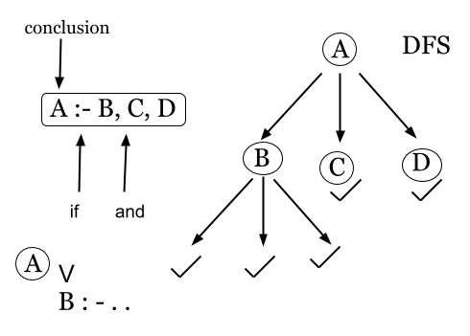
SIMPLEST FACTS FIRST!

Example 1 – Suite design for Motel 7
See suite.swi and suite.cpp

Example 2 – the family database (familyDB.pl)

The facts can be represented by the following family tree (courtesy of Dakota):
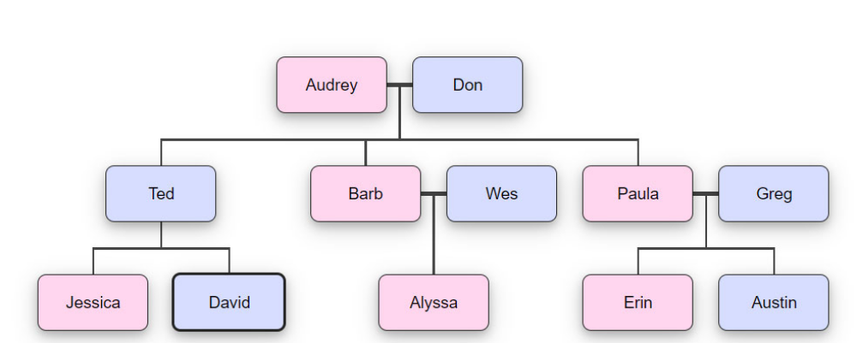

Example: grandfather(don, Y).

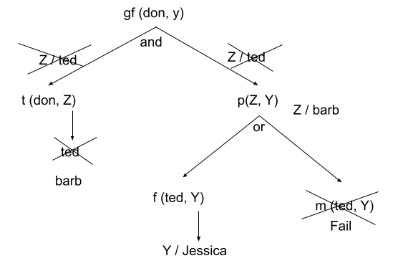

brother(X,Y)
X=don, ted

male(X) & (,) sameparent(X,Y) &(,) not(X=Y) ---> not(ted=ted) failed
not(ted=barb) →

samefather(X,Y) or (;) samemother(X,Y) % , not(samefather(X,Y))

father(F,X) & father(F,Y) mother(M,X) & mother(M,Y)

Y=barb
father(F, don) failed, mother(F, don) failed,
father(don, ted) father(don, barb)

Working with numbers

- Data types: real, integer, etc.
- Arithmetic operators (using infix notation):
+, -, *, /, ** (power), // (integer division), mod (like % in C++)
- Assignment:

- Using = % this represents a binding of a var to a symbol or in general, a pattern
% as such, there won’t be any calculation!
Var = pattern. % create binding, must be exact match,
% no computation applied. Ex.., 2+3 is NOT 3+2

?- X = 1+2 returns X = 1+2
?- 1+2 = 2+1 returns false
% What does the following generate?
?- X = 1+2, print(X).

- Using is
Var is expression % is force computation
Ex.,
T is 3*X. % T is assigned value of expression, or
0 is mod(X, 2). % true if X mod 2 equals 0, i.e., X is even
% Try this
?- X is 1+2, print(X).

- Relational operators: <, =<, >, >=, =\= (not equal), =:= (equal)
All of these operators has the ‘is’ effect on the expression
Ex.,

0 =:= mod(X, 2). % X is even

- Free variables are NOT allowed in a logical expression, except equal
Ex.,

positive(X) :- X>0. % there are infinite number of Xs
% use assert to add dynamically, ex.,
assert(positive(X) :- X>0).

positive(3). ______true_____
positive(Y). % what about this one? Error, cuz Y is not sufficiently instantiated

positive (1-4). % false

Example - factorial

factorial(N, F). % true if F is N! N is the input parameter, F is the output parameter
? - factorial(4, 24).
true.

% we can use it to get Y value from X, i.e., Y=factorial(X), but not vice versa
factorial(4, Y).
Y=24.

% factorial – base case
factorial(N,F) :- N=1, F=1.% or, could simply write factorial(1, 1).

% factorial – recursive case
factorial(N, F) :- N>1, factorial(N-1, F1), F is N*F1.
% Does this work? No, what’s the issue?

% This does NOT work because arguments of a prolog term
% cannot be an expression such as N-1.

factorial(1, 1).
% factorial(N,F) :- N=1, F=1.
factorial(N, F) :- N>1, N1 is N-1, factorial(N1, F1), F is N*F1.

- Write PROLOG rules for the Fibonacci sequence of 1 1 2 3 5 8 13 21 34 55 89… using the term fib(N, F) where
N – the position in the sequence, can be considered as input parameter
F – represents the Nth number in the sequence, it is considered the output parameter

%base case
fib(1, 1). %Yes
fib(2, 1). % Yes
:-? fib(10, Y).
Y = 55.

% general statement
fib(N, F) :- N>2, N1 is N-1, N2 is N-2, fib(N1, F1), fib(N2, F2), F is F1+F2.

- let’s define sigma

sigma(X, Y). %Y = 1+2+3+…+X

% recursive case

Working with list

Since there is NO iteration in PROLOG
- How can we repeat things, or perform the same sequence of operations?
Use rules that reduce the problem size and refer to itself.

- What’s a good way of storing a large amount of data?
List: a bunch of things in [ ], separated by , ex., [1, 2, 3 ]
[H | T] → a. list is not empty – this format does not math with an empty
b. H is the first element of the list, the T is the remainder of the list
c. Sometimes, we need to refer to the first 2 (top-level) elements, we could use
the notation: [H1, H2 | T] % this matches with any list with 2 or more elements

List Examples:

Example – getting the first and last of a list, useful

first([H|T], H). % only case for first
last([H], H). % base case for last
last([_|T], R) :- last(T, R).

- define sum/2, which has the form sum(L, S).
Ex., ?- sum([1,2,3,4], S).
S = 10.

%base case
sum([], 0).
%sum([A], A). % this could be a base case

sum([H|T], S) :- sum(T, S1), S is H+S1.

- define sumAll, which has the form sumAll(L, S). S is the sum of all of the numbers in the list L including sub-list.

%base case
sumAll([],0).

sumAll([H|T], S) :- number(H), sumAll(T, S1), S is H+S1.

sumAll([H|T], S) :- is_list(H), sumAll(T, S1), sumAll(H, S2), S is S1+S2.

- Consider writing the rules for a relation

iMember(X, L) % true if X is a member of List L

How do we describe the relation recursively?

- We describe the L as [H|T]

- There are two cases in which X can be member of L
Case 1: X matches H
Case 2: X is a member of the T

iMember(X, L) :- L = [H|T], X=H.
iMember(X, L) :- L = [H|T], iMember(X,T).

See iMember.pl

Cut (!)
- Used as a condition in rules
- Backtracking will stop at the point where ‘!’ appears.
- Double edged sward, be very careful. (more about this later)

Example:

Consider the function

Y=f(X)
= 0 (X < 3)
= 2 (X>=3 && X<6)
= 4 (X>=6)

%% Illustration of cut, works as if … else if
f(X, Y) :- X < 3, Y=0, !.
f(X, 2) :- X<6.
f(X, 4) :- 6 =< X.

%% version without cut, every condition is “if … then …”
f(X, Y) :- X < 3, Y=0.
f(X, 2) :- X>=3, X<6.
f(X, 4) :- 6 =< X.

More List Examples – append, reverse, remove contiguous

append(X, Y, Z) % true if Z contains elements of X followed by elements of Y
% i.e., Z = (append X Y) ;; scheme call

X = [1, 2, 3, 4]
Y = [a, b, c, d, e] % [H|T]
Z = [1, 2, 3, 4, a, b, c, d, e].

Let’s define our own append – iAppend

There are two ways to do this:
a. add each element of X to the beginning of Y,
b. add each element of Y to the end of X,

We will try (a) add each element from X to the beginning of Y
This also helps us determine our base case.

What is the base case?
iAppend([], [], []).

This is not a good base case as we don’t really need to break up Y.

% since we are adding element to the 2nd list, which never gets broken down,
% we will never get to the [] for the 2nd list
%iAppend(X, Y, Z) :- X=[], Z=Y. % this is also correct,
iAppend([], Y, Y). % better, allowing copy of entire 2nd list to 3rd list

Recursive case: X+Y → Z

X = [Hx|Tx]
iAppend Tx to Y
add Hx to beginning of the result of the last step

%recursive case, X has at least one element
iAppend([Hx|Tx], Y, [Hx|Tz]) :- iAppend(Tx, Y, Tz).

%iReverse(L1, L2)
iReverse([], []).
iReverse([H1|T1], L2) :- iReverse(T1, T2), append(T2, [H1], L2).

iReverseAll - reserve everything, including those in sublist

%Base case
reverseAll([]. []).
reverseAll([H1|T1], L2) :- not(is_list(H1)), reverseAll(T1, T2), append(T2, [H1], L2).
reverseAll([H1|T1], L2) :- is_list(H1), reverseAll(H1, H2), iReverseAll(T1, T2), append(T2, [H2], L2).

Sometime just listing [H|T] is not enough!

Define the term rc, which remove contiguous duplicates. For example,
rc([1,3,2,2,2,5,5,1,5], L2).
L2=[1,3,2,5,1,5].

Describe rules that handle different cases of L1.

What would L1 look like?
Consider ALL possible L1s

% Base case
% rc(L1, L2) :- L1=[], L2=[].
rc([],[]).

rc([Y], [Y]). % can I do rc([_], [_]). ?

%rc([H1, H2|T1], T2) :- H1=H2, rc([H2|T1], T2).
rc([H1,H1|T], L2) :- rc([H1|T], L2).

%rc([H1,H2|T1], L2) :- H1=\=H2, rc([H2|T1], T2), L2= [H1|T2].
rc([H1,H2|T1], [H1|T2]) :- not(H1=H2), rc([H2|T1], T2).

3. I/O in prolog
- Can be used in rules as well as goals.
- Form:
write(T)
read(T)
nl % new line

T is a variable or string in ‘ ’. Ex.,

% interface function for factorial
findFactorial() :- write(‘Please enter an integer: \n’),
read(T),
factorial(T,N),
write('factorial of ‘),write(T), write(‘ is ‘), write(N), nl.

Advanced LIST examples and exercises - focusing on efficiency

min - Write rules for min(X, Y, Z) which is true if Z is the smaller of X and Y. Ex.,
?- min(6, 7, Z). % Z = min(X,Y).

Z = 6

min(X, Y, X) :- X<Y.
min(X, Y, Y) :- Y=<X.
max(X, Y, Y) :- X<Y.
max(X, Y, X) :- Y=<X.

minmax – write rules for minmax(X, Y, L) where X is the smallest of L and Y is the largest of L. Ex.,

?- minmax(X, Y, [2,6,5,8,10,23,32,99,76,48,56]).
X=2, Y=99.

/* Version 1 – simple yet slow, with serious repetition/recursion */

minmax(H, H, [H]).
minmax(X, Y, [H|T])
:- minmax(X1, Y1, T), min(X1, H, X), max(Y1, H, Y).

Drawback of version 1
- Nothing was done when the list is initially reduced
- X, Y values are assigned values for the first time when the list is reduce to 1 element
- X, Y values are updated as the list grow back, during recursive rewind

How can we make this process more efficient?

/* Version 2 – keep track of the history, i.e., the current min and max

Use a 5ary term
minmax5(Min, Max, L, Cmin, Cmax) where

- Min and Max are (output) variables that will be instantiated ONLY ONCE at the very end, and
- Cmin, Cmax are variables that keep track of the current min and max.

// when the tail is finally empty
minmax5(Min, Max, [ ], Cmin, Cmax) :- Min=Cmin, Max=Cmax.
% or
minmax5(Min, Max, [ ], Min, Max).

// Otherwise, L has at least 1 element
minmax5(Min, Max, [H|T], Cmin, Cmax)
:- H<Cmax, H>Cmin, minmax5(Min, Max, T, Cmin, Cmax).

minmax5(Min, Max, [H|T], Cmin, Cmax)
:- H<Cmin, minmax5(Min, Max, T, H, Cmax).

minmax5(Min, Max, [H|T], Cmin, Cmax)
:- H>Cmax, minmax5(Min, Max, T, Cmin, H).

%minmax5(Min, Max, [H|T], Cmin, Cmax)
% :- min(Cmin, H, Nextmin), max(Cmax, H, Nextmax), minmax5(Min, Max, T, Nextmin, Nextmax).

How do we initialize Cmin and Cmax?
% The interface rule
Minmax3(Min, Max, [H|T]) :- minmax5(Min, Max, T, H, H).

4. PROLOG data structures – they are easy to make

Example - Stack ADT

stackEmpty([]). % used to test or initialize

stack(Top, Stack, [Top|Stack]).
/* One rule does it all:
This can be used to represent Push, Pop, or Viewtop
depending on what values are given, and what is used as new stack
push – given values for 1st and 2nd arguments, it will assign value to the
3rd argument (i.e., the stack), ex., stack(e, [a,b,c], Newstack) → Newstack=[e.a.b.c]
Pop – Given the value of the 3rd argument, it assigns values to the 1st and 2nd arguments,
ex., stack(Top, Newstack, [a,b,c,d]). → Top=a, Newstack=[b,c,d]
*/

% print from top to bottom
% base case, printStack does nothing when the stack is empty

printStack([]).
% printStack(S) :- stackEmpty(S). % ie., S = [].

printStack(Oldstack) :- stack(Top, Newstack, Oldstack),
write(Top), nl, printStack(Newstack).

% Stack application - evaluate a postfix expression stored in a list
%evalPostfix(Exp, Stack, Result).

% Call – evalPostfix([5, 6,*,10,-], [], Result).
evalPostfix([], [T], T).
evalPostfix([H|T], Stack, Result) :- number(H),
stack(H, Stack, Newstack),
evalPostfix(T, Newstack, Result).

evalPostfix([H|T], Stack, Result) :- not(number(H)),
stack(Top1, Newstack1, Stack), %pop
stack(Top2, Newstack2, Newstack1), %pop
eval(Top2, Top1, H, R),
stack(R, Newstack2, Newstack3), % push
evalPostfix(T, Newstack3, Result).

eval(Left, Right, +, R) :- R is Left+Right.
eval(Left, Right, -, R) :- R is Left-Right.
eval(Left, Right, *, R) :- R is Left*Right.
eval(Left, Right, /, R) :- R is Left/Right.

Query:
?- evalPostfix([5,6,*,10,-], [], R).
R= 20

% interface – so that the user will not have to specify the initial empty stack
evalPost(Exp, Result) :- evalPostfix(Exp, [], Result).

5. Unification as (Depth-first) Search

Example 1 The Farmer, Wolf, Goat, Cabbage program

The problem
A farmer with his wolf, goat, and cabbage come to the east side of a river they wish to cross. There is a boat at the river’s edge, but, of course, only the farmer can row it. The boat can carry two things (including the rower) at a time. If the Wolf is ever left alone with the goat (with or without the cabbage), the wolf will eat the goat. Similarly, if the goat is left alone with the cabbage, the goat will eat the cabbage. Device a sequence of actions so that all four characters arrive safely on the west side of the river.

Data Structure
Each problem state can be represented as [FL, WL, GL, CL], where
$L is the location of the character $. Ex., The initial state could be represented by [w,w,w,w].

GOAL
fwgc([w,w,w,w], [e,e,e,e],Path).

Preparations

opposite(e, w).
opposite(w, e).
%what about opposite(s, n)

The moves: we define a functor named move/2

move(Current, Next) is true (i.e., acceptable) if

Next = Current + action
^
Farmer takes self,
Farmer takes wolf
Farmer takes goat
Farmer takes cabbage
and Next is safe or not(unsafe).
Which one is easier to describe, safe or unsafe? unsafe

Ex.,
?- move([e,e,w,e], Next).

Next=[w,e,w,e] ;
Next=[w,w,w,e] ;
Next=[w,e,w,w] ;
false

% 1. Farmers take self
move([FL,WL,GL,CL], [FL1, WL,GL, CL])
:- opposite(FL, FL1), not(unsafe([FL1, WL,GL,CL]).

% 2. Farmers take wolf
move([FL,FL,GL,CL], [FL1, FL1,GL,CL])
:- opposite(FL,FL1), not(unsafe([FL1, FL1, GL,CL]) .

Defining unsafe – specify the state that are unsafe, one state at a time
In all of the following cases, the goat would eat the cabagge
unsafe([e,e,w,w]).
unsafe([w,w,e,e]).
unsafe([e,w,w,w]).
unsafe([w,e,e,e]).

unsafe([FL, FL, GL, GL]) :- opposite(FL, GL). % or not(FL=GL) =/=

unsafe([FL, _, GL, GL]) :- not(FL=GL).
unsafe([FL, WL, WL, __]) :- opposite(FL, WL).

Solving the puzzle

?- fwgc([e,e,e,e],[w,w,w,w],Path).
Path=[[e,e,e,e],[w,e,w,e],[e,e,w,e],[w,w,w,e],[e,w,e,e],[w,w,e,w],[e,w,e,w],[w,w,w,w]]
Path=[[e,e,e,e],[w,e,w,e],[e,e,w,e],[w,e,w,w],[e,e,e,w],[w,w,e,w],[e,w,e,w],[w,w,w,w]]

This is relatively simple!

% base case – solution found
fwgc1(Current, GoalState, PathSoFar, SolutionPath) :-
Current=GoalState, reverse(PathSoFar, SolutionPath).

% recursive case, making moves, one at a time.
fwgc1(Current, GoalState, PathSoFar, SolutionPath)
:- move(Current, Next), not(member(Next, PathSoFar)),
fwgc1(Next, GoalState, [Next|PathSoFar], SolutionPath).

What’s the initial value of PathSoFar? A list of one state, the initial state
fwgc1([w,w,w,w],[e,e,e,e], [[w,w,w,w] ], SolutionPath)

% interface
fwgc(Current, GoalState, Path) :-
fwgc1(Current, GoalState,[Current],Path), pprint(Path).

Who does the search? Prolog implementation system, ex., swi-prolog

What kind of search? Depth-first search

[e,e,e,e] (initial)

[w,e,e,e] UnSafe [w,w,e,e] US [w,e,w,e] Safe [w,e,e,w] US

[e,e,w,e] S [] [e,e,e,e] S & Repeat []

What’s our responsibility?

- Specify the rules for changing from one state to another, i.e., the moves
- Keep a history of the states visited (at least in the current path)

Can we have more control in the search process?

Set a limit on how far we will go - see jugs program

